Modify the big_num class for week 6 question so that it will no longer use vectors but use dynamic arrays instead. Remember to include a copy constructor, overload = and the deconstructor.

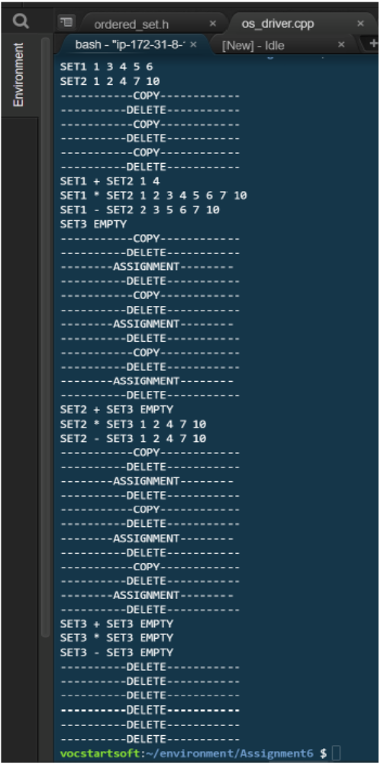
With the given os_driver.cpp. Write a order_set.h file so that the or_driver file will output the following. You must implement your order_set class using a dynamic array. You must write a destructor, a copy constructor and overload the assignment operator. Your destructor must print DELETE, the copy constructor must print COPY and the overloaded assignment operator must print ASSIGNMENT. See the example on the next page. You can not hard code your answer. Note that your assignment, delete and copy statements may differ slightly based on implementation. You must includes the -fno-elide-constructors flag compiling your program.

